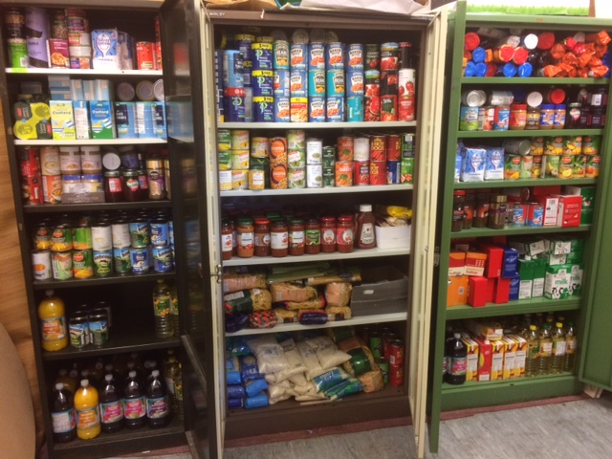
The cupboards are fully stocked after generous donations, including a special grant from Admiral Scaffolding.
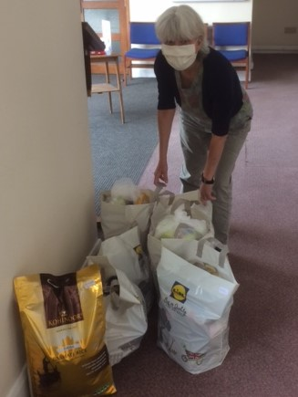
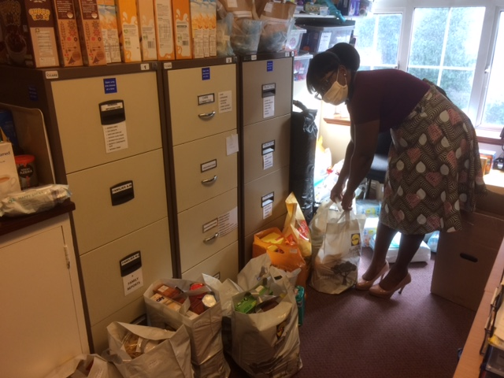
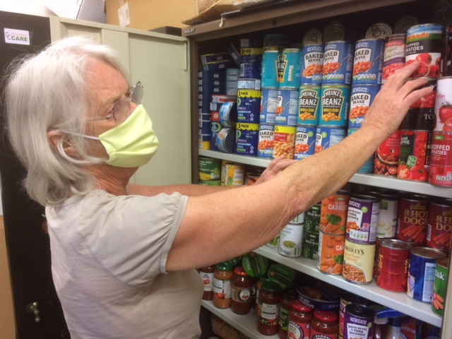

Our longest serving befriender and shopper selects the groceries for a family of four.

Our latest volunteer collects from an office filled with bags pre-packed by the Coordinator.

Like all the volunteers our Chair wears one of the 850 face coverings donated by a Wimbledon High School parent.

