A member of the Drive and Drop team has stepped in to help cover deliveries during the holiday period.
The bags are delivered to the door and the children help to carry them in. There is a special surprise for them – picnic goodies!
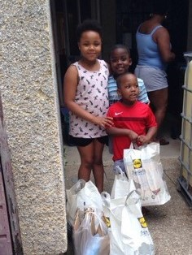
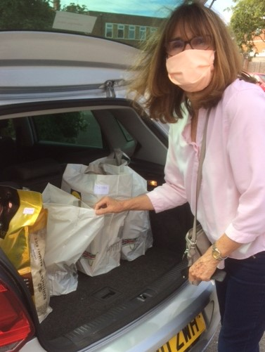
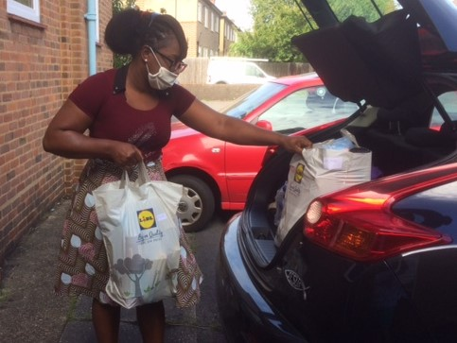
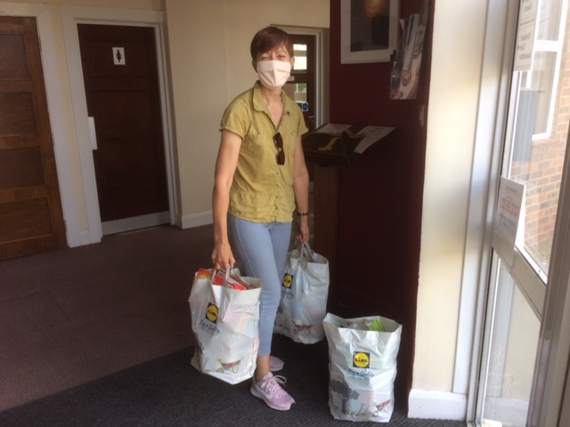

The volunteers have so much to fit into their cars as they are taking supplies for a whole month.

Another member of the Drive and Drop team goes out to see family that is shielding.

